CS 4820

Artificial Intelligence
Fall 2017
Instructor Dr. Zhiguang Xu
Project 1: Evolving game AI behaviors using ANN with
back-propagation algorithm
Due by September 26, 2017 (12:30pm)

- Introduction
In this project, we will use the Artificial Neural Network (ANN) to select an action from an available set based upon the current situation perceived by the character within the game environment. The project will be implemented in Java.
The rationale for using ANN as neural-controller here (the usage of ANN and neural-controller are synonymous in the following discussions) is that we can’t practically give a game AI character a set of behaviors that covers all possible combinations of perceived environment. Therefore, we train the ANN with a limited number of samples where each sample is a particular environment and the corresponding desired behavior, and then let it generalize all of the other situations to provide proper responses. The ability to generalize and provide proper reactions to unknown situations is the key strength of the neural-controller design.
- ANN architecture
In the example of exclusive-OR, an ANN with a single output neuron was discussed in detail in class. For the game AI character, although we stick with the three-layer back-propagation neural network in general, we will look at another architecture called a “winner-take-all” network (Figure 1).
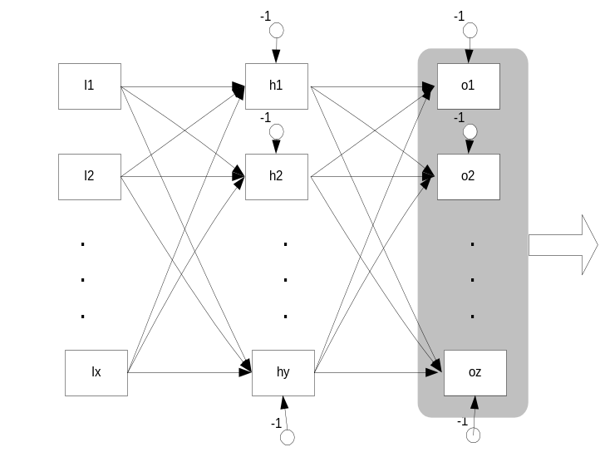
Figure 1: A “winner-take-all” network

In the “winner-take-all” network, the output neuron with the highest output is the winner of the group and is allowed to fire. In our application each output neuron represents a distinct behavior that is available to the character within the game. Example behaviors include attack, run-away, wander, hide, etc. The firing of a neuron within the winner-take-all group causes the character to perform the particular corresponding behavior.
The number of input neurons is determined by the number of different types of situations that can be perceived and processed by the neural-controller. Example situations are health, has-gun, has-knife, number of enemies in the field of view, etc.
The number of hidden neurons is determined largely by trial-and-error. It turns out that three hidden neurons that are fully connected with all input and output neurons could be trained for all presented samples with 100% accuracy within some reasonable time. You are encouraged to try other connectivity and topology, but keep it in your mind that decreasing the number of neurons might result in a network that couldn’t successfully classify all samples; whereas increasing the number of neurons might end up with a network that takes too long till convergence.
Table 1 and table 2 show all the available inputs and behaviors respectively. These behaviors are very high-level, and it’s anticipated that the behavior subsystem will take the selected action and follow-through.

Table 1: Inputs
Input | Value | Meaning
 | 0 | Poor
Health | 1 | OK
 | 2 | Good
Has-Knife | 0 | No
 | 1 | Yes
Has-Gun | 0 | No
 | 1 | Yes
Enemies | 0,1,2,3… | Number of enemies in field of view

Table 2: Behaviors
Behavior | Value | Meaning
Attack | 0 | No action
 | 1 | Attack the peer(s)
Run | 0 | No action
 | 1 | Flee the current position
Wander | 0 | No action
 | 1 | Random movement
Hide | 0 | No action
 | 1 | Seek shelter

- Training the ANN
We will use the sigmoid function 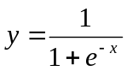as our activation function and choose the learning rate α = 0.1.
  - Training samples
Training the neural-controller consists of presenting training input samples to the ANN, and then performing the back-propagation on the network given the desired result and the actual result. For example, if the character is in possession of a gun and is healthy and in the presence of a single enemy, the desired behavior may be to attack, i.e., take a shot. However, if the character is healthy, in possession of a knife, but in the presence of two enemies, the correct action would be to hide. Since we want the neural-controller to behave in a more life-like fashion, we will not train the neural-controller for every case. Therefore, the network will generalize the inputs and provide an action that should be similar to other scenarios for which it was trained. We will discuss the testing policies more in the next section.
The samples used to train the network are presented in table 3. They are provided to you as two 2-dimensional arrays double [][] inputs and double [][] desiredOutputs defined in a Java interface called samples.java. The columns in inputs represent Health, Knife, Gun, and Enemies from left to right, and the columns in desiredOutputs represent Attack, Run, Wander and Hide from left to right. For example, the 1st row in table 3 corresponds to inputs [0] = {2.0, 0.0, 0.0, 0.0} and desiredOutputs [0] ={0.0, 0.0, 1.0, 0.0}. Your program needs to implement it in order to get access to those arrays.

Table 3: Training samples used for ANN (18 in total)
Health | Has-Knife | Has-Gun | Enemies | Desired Behavior
2  An epoch | 0 | 0 | 0 | Wander
2 | 0 | 0 | 1 | Wander
2 | 0 | 1 | 1 | Attack
2 | 0 | 1 | 2 | Attack
2 | 1 | 0 | 2 | Hide
2 | 1 | 0 | 1 | Attack
1 | 0 | 0 | 0 | Wander
1  An iteration | 0 | 0 | 1 | Hide
1 | 0 | 1 | 1 | Attack
1 | 0 | 1 | 2 | Hide
1 | 1 | 0 | 2 | Hide
1 | 1 | 0 | 1 | Hide
0 | 0 | 0 | 0 | Wander
0 | 0 | 0 | 1 | Hide
0 | 0 | 1 | 1 | Hide
0 | 0 | 1 | 2 | Run
0 | 1 | 0 | 2 | Run
0 | 1 | 0 | 1 | Hide

  - Convergence
During the process of training, the completion of each sample (each row in table 3) is called an iteration. The sum of the squared errors of all output neurons, called iteration error, is obtained. The completion of all 18 samples (all 18 rows in table 3) is called an epoch. In turn, the sum of all iteration errors within the epoch, called epoch error, is obtained. The training is finished when the epoch error is smaller than a predefined threshold; or the total number of epochs exceeds an upper bound. In our case, you may use 0.01 and 1,000,000 respectively.
Note, it is not abnormal that the same ANN converges with one set of initial weights but diverges with another set of them. So, don’t panic if your network does not converge even when you have exhausted the max number of epochs. It happens, just give it another shot.
I will feel regretful if I don’t mention that it is ideal to choose the samples within an epoch randomly while training. But in order to simplify the project, it is ok for you to run them against the network sequentially, although the performance won’t be the best. We will discuss how to test and evaluate a training network in the next section.
  - Accelerating training
As we discussed in class, in general, we can accelerate training of an ANN by including a momentum term in the delta rule (Eq. 6.17 on page 185 in your text book):
where β is the momentum constant (set to 0.95).
You are required to implement the technique above and run your neural-controller with or without the momentum constant in effect based on the value of a command-line argument.
  - Programming hints
It is a good practice for you to apply the knowledge of object-oriented programming you learned before. For example, you might want to design your neural-controller as a general, standing-alone class and encapsulate all data and methods related to game AI characters in another class separately.

- Testing the ANN
One way to evaluate an ANN is the speed of convergence, as we discussed in the previous section. Another way, and also more importantly, is to see if the ANN makes correct decisions after being trained. We will test our ANN in two steps.
First of all, sample inputs that we used for training are presented to the network to identify how it would react to scenarios for which it has some knowledge already. In most cases, all samples in table 3 are successfully trained. In some runs, up to two examples result in improper actions.
Secondly, new examples like the ones presented in table 4 are given to the network. These tests give us an understanding of how well the neural-controller can generalize the response with desired actions for unseen examples.
Table 4: Test samples illustrating successful ANN generalization
Health | Has-Knife | Has-Gun | Enemies | Behavior
Good (2) | Yes | Yes | 1 | Attack
OK (1) | Yes | Yes | 2 | Hide
Poor (0) | No | No | 0 | Wander
Poor (0) | Yes | Yes | 1 | Hide
Good (2) | No | Yes | 3 | Hide
Good (2) | Yes | No | 3 | Hide
Poor (0) | Yes | No | 3 | Run
The examples in the table above are given to you as arrays in a java interface file tests.java as well. The format and semantics of the arrays are the same as the ones in samples.java. Implement both java interface files for training and testing your ANN.

- Additional functionalities
  - Other activation functions
Besides the sigmoid function, there are some other activation functions that are commonly used. Based on my experience, some of them will help decreasing the time of training, some of them will simply not. You are encouraged to explore them and see what they do. Note, you have to figure out the derivatives for them before using them. I just list four below; you won’t find it hard to find more on-line yourselves.
- Hyperbolic tangent (1) 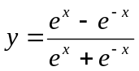
- Hyperbolic tangent (2) 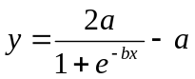, where a, b are constants (e.g. a = 1.716, b = 0.667; or a = b = 1)
- Hyperbolic tangent (3) 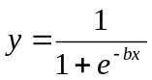 , where b is a constant (e.g. b = 0.667 or b = 1)
- Gaussian 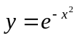
You are required to implement at least the hyperbolic tangent (2) function. Others are optional.
  - Presenting running results
You will use matlab to plot figures when composing your report. Alternatively, you may use scilab, a free scientific software package, or anything that you feel comfortable with. The most current release of scilab is 6.0.0 which can be downloaded at http://www.scilab.org. Follow the instructions there for installation. It is very standard.
The following is a sample matlab script called ann.m, which can also be found on blazeview:
y=[17.33191 0.77157 0.20897 0.11402 0.07702 0.05768 0.04589 0.03800 0.03236 0.02814 0.02487 0.02226 0.02013 0.01837 0.01688 0.01562 0.01452 0.01356 0.01272 0.01198 0.01132 0.01072 0.01018 ]
x=[0:1000:22366]
plot(x,y)
grid()
title('Sum-squared network error without momentum constant')
xlabel('Epoch')
ylabel('Sum-squared error')
legend('Activation functon: sigmoid')
Everything is standard except the values of x and y vectors. They were obtained when I ran my program without the momentum option.
- How to run your program
Your program gamecharacter will be executed in the following way:
- java gamecharacter [0.0|0.95] [activation function]
There are two optional command-line arguments. The first argument is the momentum constant, which is either 0 (default) or 0.95. The second is the activation function, which could be either sigmoid (default) or ht2, or any other function that you clearly describe in your final document.

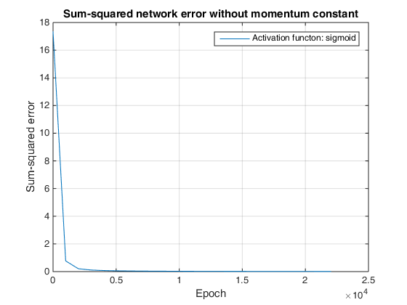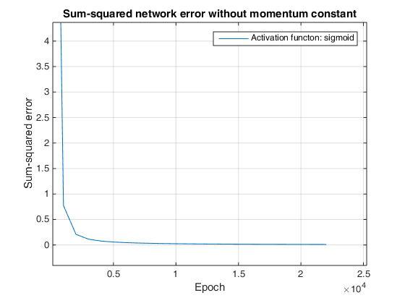
Zoom
In
- Grading criteria
Your grade will be determined based on the quality of the execution, source code, and all reports of your project.

The following grading criteria will be used:

Functionalities and Correctness 85%
Documentation 15%
Informal Progress Report (Due 09/12
through Blazeview Email) 2%
Final Project Report (Due 09/19, see below) 13%

You will need to write up a final project report documenting your system, which should discuss:

- Motivations for your work
- Objectives you want to achieve and your approaches to achieving them.
- Software components/classes and architecture of your system. This should be a major section of your report. You should explain in detail the functions of each component/class, and how components interact with each other. You should also describe the principle data structures and network messages in your system.
- Running results. This is another major section. You are asked to include and explain the running results of your program. Charts, figures, and tables will always help.
- Discussions of your work. Describe its major strengths and weaknesses. Include the features you would like your system to have, but did not do because of resource/time limitations.

